* Chat is a popular feature. Chat is used for discussion and also for teachers to poll students.

* We analyzed 6 chat sessions throughout the quarter.

* A summary of discussion messages is below:

All responses

|  |  |  |  |  |
| --- | --- | --- | --- | --- |
| Date | #student-discussion-messages | #students-participate-at-least-once | #students-participate-at-least-3-times | #messages-from-teachers |
| 10/02/19 | 1171 | 74 | 69 | 14 |
| 10/18/19 | 654 | 61 | 48 | 46 |
| 10/30/19 | 531 | 54 | 39 | 0 |
| 11/13/19 | 369 | 55 | 42 | 25 |
| 11/18/19 | 925 | 62 | 53 | 28 |
| 11/22/19 | 523 | 54 | 36 | 29 |
| Averages | 696 | 60 | 48 | 24 |

Normal responses

|  |  |  |  |  |
| --- | --- | --- | --- | --- |
| Date | #student-discussion-messages | #students-participate-at-least-once | #students-participate-at-least-3-times | #messages-from-teachers |
| 10/02/19 | 350 | 48 | 21 | 10 |
| 10/18/19 | 384 | 42 | 21 | 21 |
| 10/30/19 | 346 | 40 | 20 | 0 |
| 11/13/19 | 204 | 43 | 23 | 17 |
| 11/18/19 | 578 | 43 | 21 | 15 |
| 11/22/19 | 352 | 35 | 19 | 19 |
| Averages | 369 | 42 | 21 | 14 |

Poll responses

|  |  |  |  |  |
| --- | --- | --- | --- | --- |
| Date | #student-discussion-messages | #students-participate-at-least-once | #students-participate-at-least-3-times | #messages-from-teachers |
| 10/02/19 | 821 | 73 | 69 | 4 |
| 10/18/19 | 270 | 57 | 45 | 21 |
| 10/30/19 | 185 | 51 | 35 | 0 |
| 11/13/19 | 164 | 53 | 30 | 8 |
| 11/18/19 | 347 | 61 | 50 | 13 |
| 11/22/19 | 171 | 49 | 31 | 10 |
| Averages | 326 | 57 | 43 | 9 |

* A summary of poll messages: (same data but with different axises)

|  |  |  |  |  |  |  |  |
| --- | --- | --- | --- | --- | --- | --- | --- |
| Date: | Unknown | 10/02/19 | 10/18/19 | 10/30/19 | 11/18/19 | 11/22/19 | Average Number of Responses |
| Poll |  |  |  |  |  |  |  |
| 1 | 20 | 48 | 12 | 20 | 49 | 40 | 32 |
| 2 | 9 | 48 | 20 | 17 | 70 | 10 | 29 |
| 3 | 14 | 47 | 36 | 8 | 47 | 18 | 28 |
| 4 | 11 | 48 | 39 | 8 | 56 | 16 | 30 |
| 5 | 21 | 44 | 45 | 42 | 30 | 20 | 34 |
| 6 | 11 | 27 | 19 | 12 | 33 | 22 | 21 |
| 7 | 10 | 24 | 41 | 15 | 40 | 33 | 27 |
| 8 | 27 | 39 | 26 | 21 | 22 | 12 | 25 |
| 9 | 27 | 33 | 32 | 14 |  |  | 27 |
| 10 | 14 | 34 |  | 10 |  |  | 19 |
| 11 |  | 13 |  | 10 |  |  | 12 |
| 12 |  | 40 |  | 8 |  |  | 24 |
| 13 |  | 31 |  |  |  |  | 31 |
| 14 |  | 32 |  |  |  |  | 32 |
| 15 |  | 37 |  |  |  |  | 37 |
| 16 |  | 40 |  |  |  |  | 40 |
| 17 |  | 38 |  |  |  |  | 38 |
| 18 |  | 32 |  |  |  |  | 32 |
| 19 |  | 39 |  |  |  |  | 39 |

|  |  |  |  |  |  |  |  |  |  |  |  |  |  |  |  |  |  |  |  |  |
| --- | --- | --- | --- | --- | --- | --- | --- | --- | --- | --- | --- | --- | --- | --- | --- | --- | --- | --- | --- | --- |
| Date | Poll 1 | Poll 2 | Poll 3 | Poll 4 | Poll 5 | Poll 6 | Poll 7 | Poll 8 | Poll 9 | Poll 10 | Poll 11 | Poll 12 | Poll 13 | Poll 14 | Poll 15 | Poll 16 | Poll 17 | Poll 18 | Poll 19 | Poll 20 |
| Unknown | 20 | 9 | 14 | 11 | 21 | 11 | 10 | 27 | 27 | 14 |  |  |  |  |  |  |  |  |  |  |
| 10/02/19 | 48 | 48 | 47 | 48 | 44 | 27 | 24 | 39 | 33 | 34 | 13 | 40 | 31 | 37 | 40 | 38 | 32 | 39 | 41 | 33 |
| 10/18/19 | 12 | 20 | 36 | 39 | 45 | 19 | 41 | 26 | 32 |  |  |  |  |  |  |  |  |  |  |  |
| 10/30/19 | 20 | 17 | 8 | 8 | 42 | 12 | 15 | 21 | 14 | 10 | 10 | 8 |  |  |  |  |  |  |  |  |
| 11/18/19 | 49 | 70 | 47 | 56 | 30 | 33 | 40 | 22 |  |  |  |  |  |  |  |  |  |  |  |  |
| 11/22/19 | 40 | 10 | 18 | 16 | 20 | 22 | 33 | 12 |  |  |  |  |  |  |  |  |  |  |  |  |
| Averages | 32 | 29 | 28 | 30 | 34 | 21 | 27 | 25 | 27 | 19 | 12 | 24 | 31 | 37 | 40 | 38 | 32 | 39 | 41 | 33 |

* Below are two plots showing # of messages per minute for 2 chat sessions

Date: 10/18/19

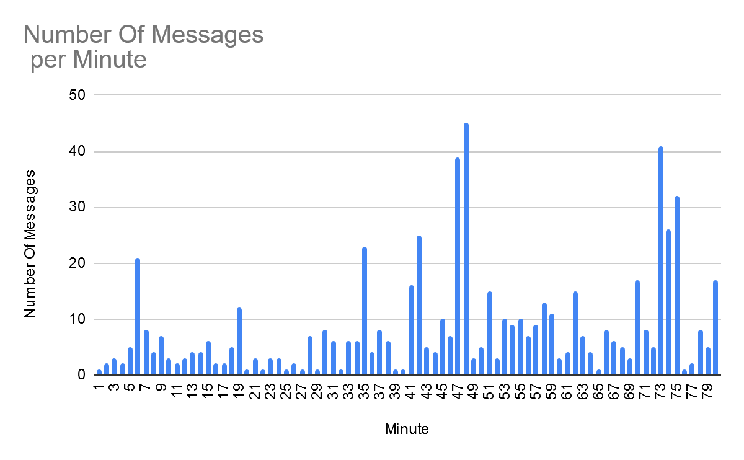

Date: 11/13/19

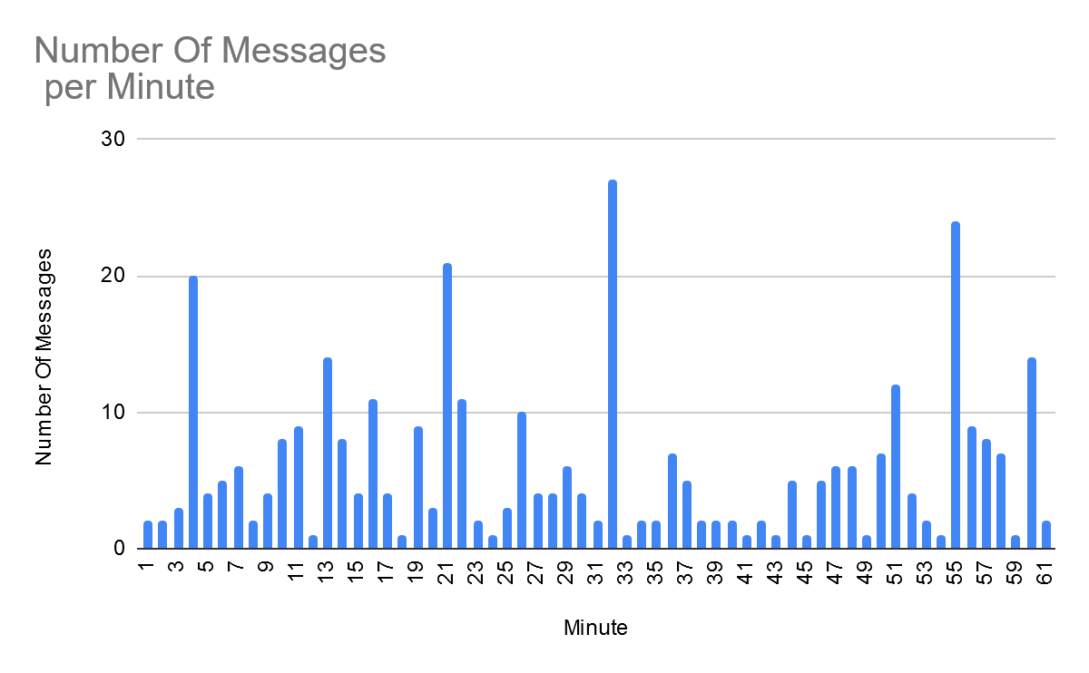

* Below is a plot showing the average discussion rate per student for the 6 sessions analyzed.

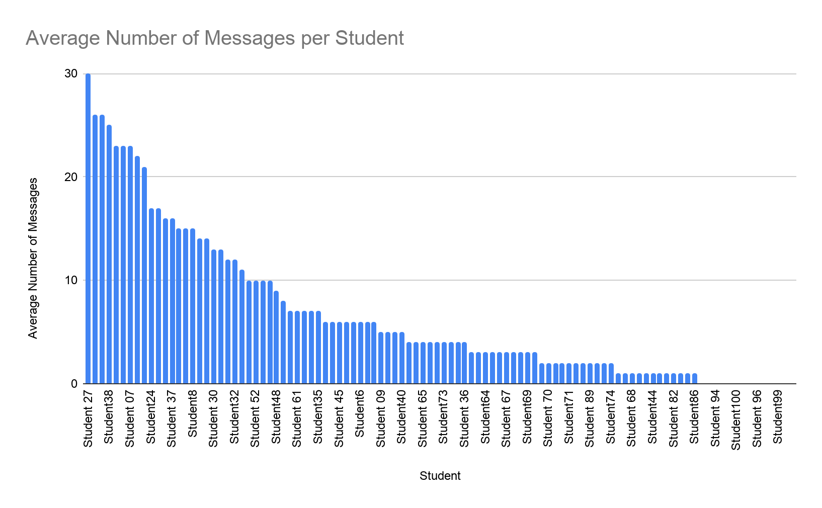

Student 27: Rank 2

“Would we get marked down if we put an excessive array size”

“I think this is better than the flipped classroom”

“He never declared integer i”

“Is the MT as oddly worded as the sample exam?”

“No curve right?”

“Joe Money!”

“Can we omit the zeros”

“If grades[i] > currMax Put grades [i] to output ?”

“Flowchart please”

Student 13: Rank 34

“array index too large”

“yes”

“So the whole exam is what, 75 points?”

“oh cool”

“brute force’

“better than on paper”

“Thanks Dr. Vahid & Joe. Have a great weekend everyone!”

Student 42: Rank 72

“that’s so cool”

“averageNum = (x+y+z)/3”

“i had one yesterday:(“

“the array is only set at 5”

“thank youuuu”

“can you check mine too please?”

* Figure out a plot to show participation in polls as well...

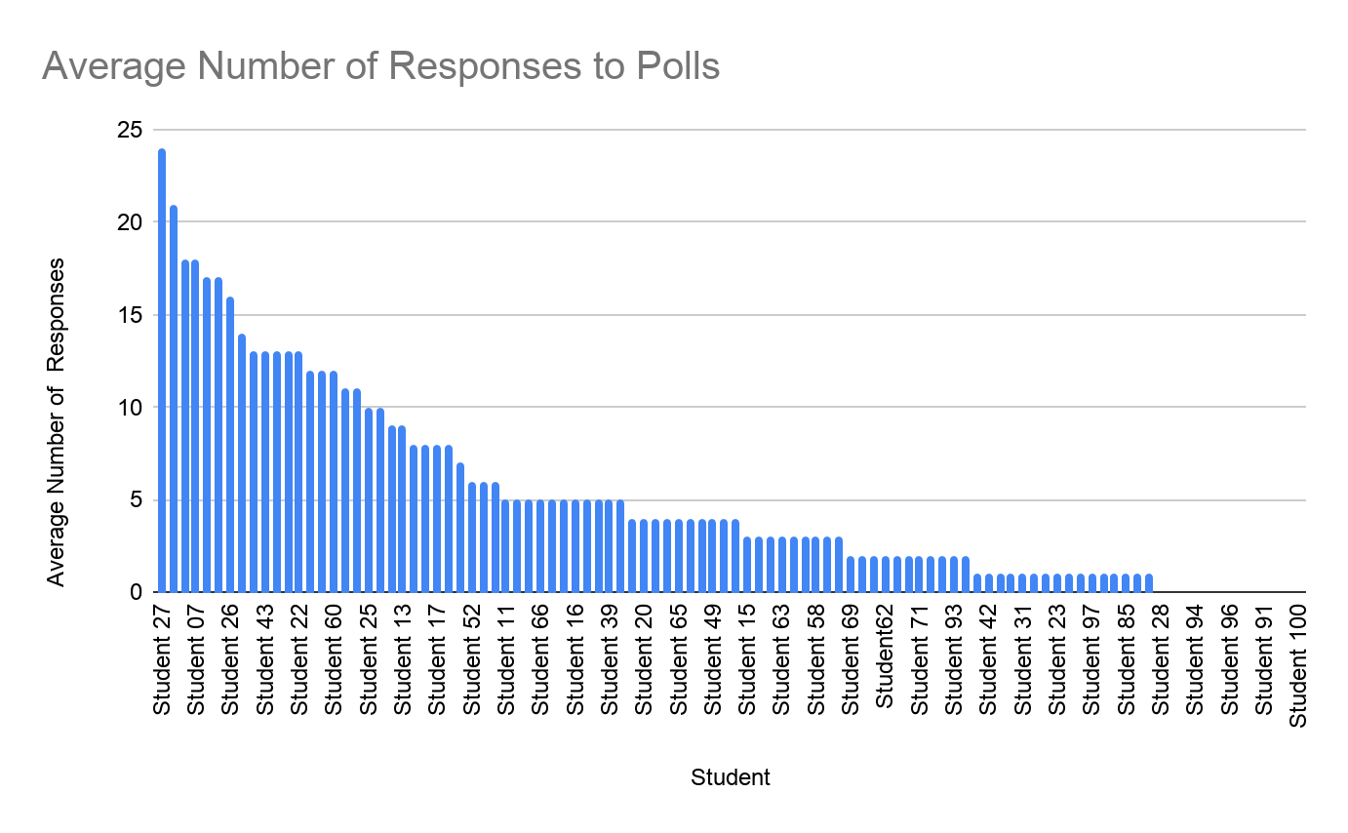

* We manually analyzed 1 session to determine the kinds of chat messages. Below is a breakdown by category. (We might have you manually analyze another later).

A technical question is a question related to coding logic or syntax.

A class structure questions is a question related to the class format and assessment dates.

Providing an answer is when a student or teacher provides an answer to a students question in chat.

If a student did not receive an answer to their question then the message is marked as did not receive an answer.

Friendly banter is casual chatter between students unrelated to the academic topics in class.

Students feeling good is categorized when a students message conveys a cheerful mood.

A poll response is the students responses to a question the professor has asked.

|  |  |
| --- | --- |
| Technical Questions | 22 |
| Class Structure Question | 9 |
| Providing An Answer | 27 |
| Did Not Receive An Answer | 1 |
| Friendly Banter | 92 |
| Students Feeling Good | 9 |
| Poll Response | 150 |

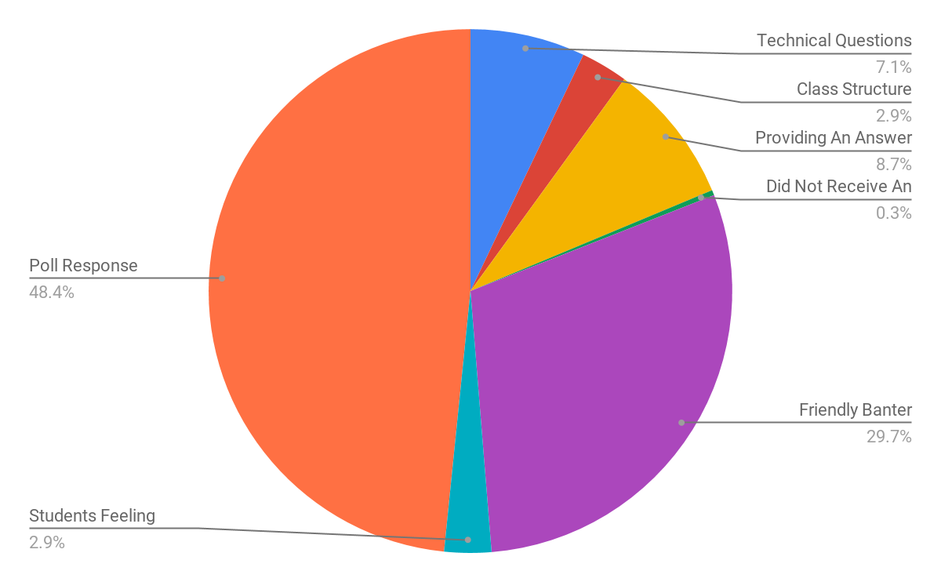

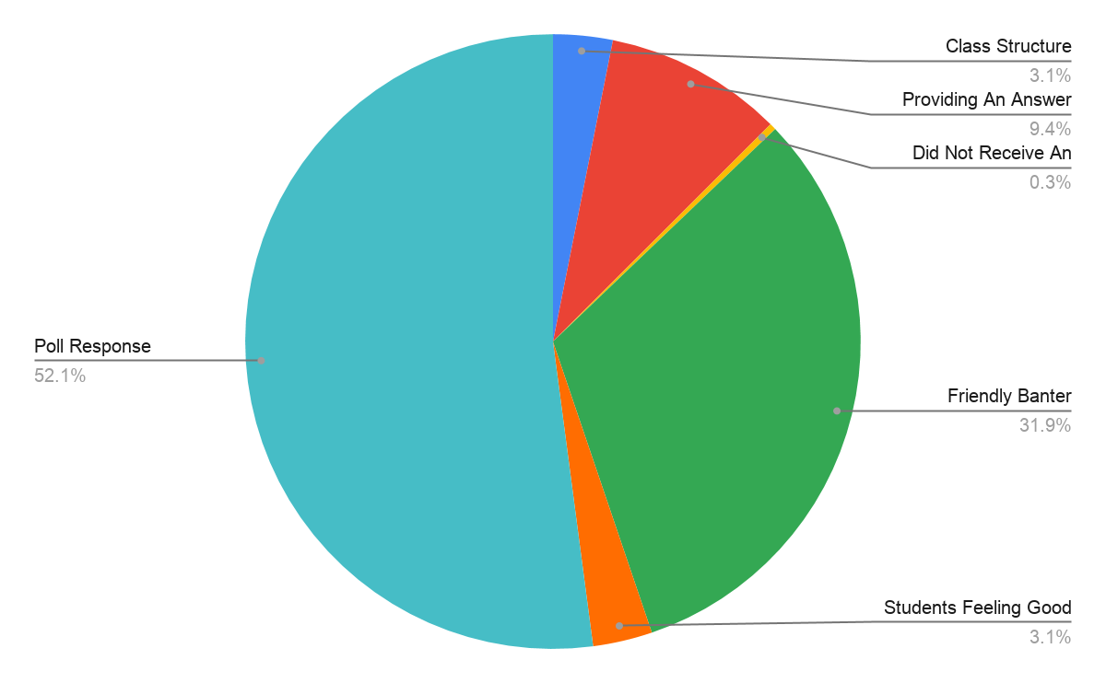

* Below are sample messages in each category.

Technical Questions:

“so everything inside the { } is part of the while loop correct?”

“Are we allowed to use the increment shortcuts like +=”

“are we going to go over the difference between ++i and i++?”

“how would someone handle the first birthday?”

“what does namespace std do?”

Class Structure Questions:

“could someone repost the link?”

“do the in person cs classes also have lab and lecture at the same date?”

“may I get the googl eform”

“did survey get sent im bit late”

“is cs13 not being offered next quarter?”

“im so late, was there a survey?”

“Was running late sorry was there a survey?”

Providing An Answer

“For all that don't know what += is, we can talk about it in lab tonight!”

“It's called the loop body!”

“if you have more, then it will output whatever character is after 'z' in the ascii table”

“c code is very similar to c++. There are some differences, but since we copied the code into a c++ compiler - then in this case it worked out”

Did Not Receive An Answer

“I have listed a question a few lines up ^^”

Friendly banter

“I took all my midterms already, and drank away my sorrows”

“theres no time for minecraft :(“

“i have no control”

“:/”

“my aunt one time used matches as candles…”

“bruh”

“there’s a show on netflix called “explained” and there’s an episode about coding, its interesting!”

“if i had a dollar for each domain name”

“creates email spam*”

“Dam there goes all my ideas”

“but why?”

“coke.com”

“LOLL”

“lol”

“internet.com omg”

“WHAT”

“smart guy”

“lucky guy”

Students feeling good

“Great!’

“;-; I'm finally famous guys.”

“That’s cool”

“That’s why its in beta xD”

“Lolz”

“Three cheers of Joe!”

“Hip hip”

“He's gorgeous”

“Hooray!”

“horray”

“JOE 2020”

“Its the beard”

“Hip hip”

“Horray”

“a god”

“Hooray!”

“its the smile”

“lmao JOE 2020”

“hip hip”

“hooray!”

“Joe, whats your favorite pizza and where should I send it”

Poll Responses

“!=”

“!n”

“!=”

“!=”

“!=”

“!=”

“!=”

“userChar != q”

“!=”

“!=”

“!=”

“!=”

“numBdays?”

“numbdays”

“numBdays???”

“N umBdays”

“numbdays”

“cin >> userCgar”

“Cin << userchar”

“cin << userchar”

“cin >> userChar”

“cin>>userChar”

“rand()”

“%100”

“%100”

“% 100”

“%100”

* Attendance per student

